**How the Soap service in your project can make the program easier for the developer.**

First of all, SOAP relies on XML, and together with schemas, it defines a very strong typed messaging framework. XML messages have a defined structure called - SOAP MESSAGE.   
SOAP MESSAGE consists of:

* Envelope – root of an element of a SOAP message.
* Header – information about the message.
* Body – contains actual data of request meant to be sent to the server.

As was already mentioned, the SOAP message itself must be XML-formatted. As is normal for any XML document, there must be one root element: the Envelope in this case. This contains two required elements: the Header and the Body.

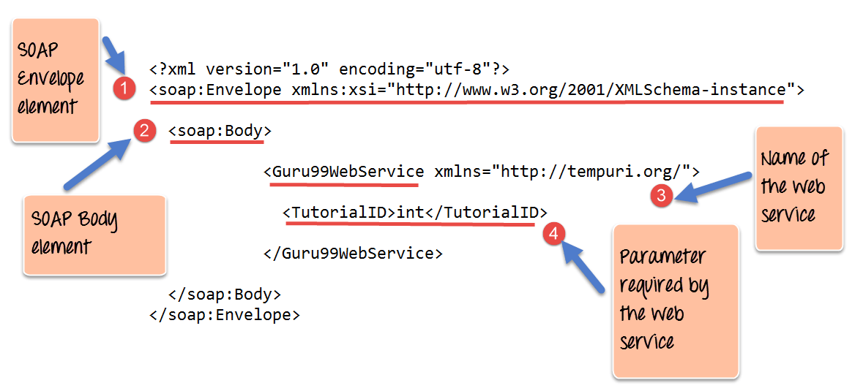

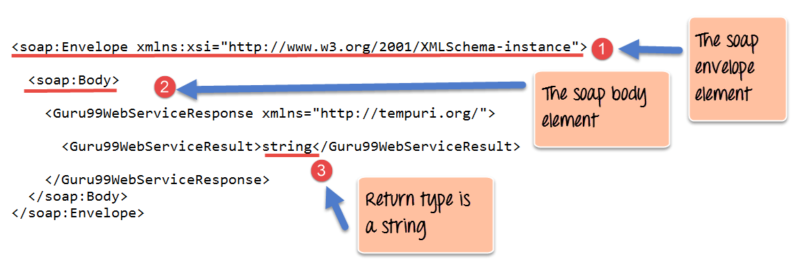

Since SOAP uses XML it‘s more readable, it‘s easy to pick what kind of information needs to be picked and manipulated. XML in SOAP is also platform and language independant so it‘s pretty easy to use on any system.